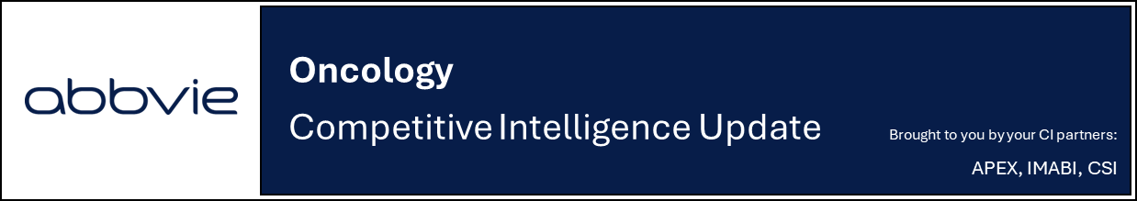
Nurix announces advancement of bexobrutideg into registrational Ph 2 DAYBreak-CLL-201 trial in 3L+ R/R CLL in investor update
Company: Nurix  Drug: Bexobrutideg (NX-5948, BTK degrader) | Date: Oct 22, 2025  Source(s): Oct 2025 Presentation, Press Release
What happened:
- Nurix initiated the single-arm global pivotal Ph 2 DAYBreak-CLL-201 trial evaluating bexobrutideg (NX-5948, BTK degrader) monotherapy in patients with R/R CLL (in line with previous company guidance)
  - The study is designed to support potential accelerated approval in R/R CLL and will evaluate bexobrutideg 600 mg QD in ~100 R/R CLL patients who have experienced disease progression following treatment with a cBTKi, a BCL2i, and an ncBTKi (triple-exposed)
  - The company anticipates rapid enrollment, with data potentially available by 2027 (new guidance)
- Nurix provided new head-to-head preclinical data underscoring bexobrutideg's potential best-in-class profile
  - Potency: 20x more potent than BeOne’s catadegbrutinib and 5x more potent than AbbVie degrader compound (likely ABBV-101) in BTK degradation
  - Selectivity: Global proteomics showed bexobrutideg degraded only BTK, while competitors showed off-target degradation (TEC, ADK, LCK, CSK)

Impact (CI PoV): Medium
- The pivotal Ph 2 study is underway for bexobrutideg, aimed to support accelerated approval, with approval anticipated in 2028; the Ph 3 confirmatory study is designed to support broad global regulatory submissions

Why it matters (CI Insights in blue italics):
- The Ph 2 design in 3L+ R/R CLL reflects an anticipated shift in the salvage treatment paradigm
  - As the salvage R/R CLL setting evolves, Nurix’s trial design is factoring in potential upcoming approvals of other assets into its inclusion criteria
    - The study is designed to include patients previously treated with a ncBTKi, such as Lilly’s Pirto, which was recently approved in the EU and anticipated to be approved in the US in 4Q 2025 based on the Ph 3 BRUIN CLL-321 study (post-BTKi R/R CLL, pirtobrutinib, N=238)
  - With commencement of the DAYBreak trial in 3L+ CLL, Nurix is on track for an accelerated approval projected for 2028 (CI assumption), contingent on a successful AA pathway
    - Assuming an aggressive timeline based on a data readout and submission in 1Q 2027, earliest approval could be observed in 1Q 2028
- The confirmatory trial in 2L+ R/R CLL is poised to support broad global regulatory submissions
  - The Ph 3 confirmatory trial of bexobrutideg is strategically designed to align with diverse 2L SoC across regions; pirtobrutinib is expected to be utilized for most of the 2L setting in the US/EU, Idela + R for high-risk EU patients, and B + R prevalent in ROW
    - This Ph 3 confirmatory trial design of bexobrutideg enables comparison across all three control arms, compared to two separate studies (CaDAnCe-304: H2H vs. Pirto; CaDAnCe-302: vs. investigator’s choice) for BeOne’s catadegbrutinib
  - The clear PFS benchmarks for the Ph 3 control arm (~9 months for BR/IR, ~14 months for pirtobrutinib, per BRUIN CLL-321) provide a tangible basis for evaluating bexobrutideg’s potential superiority

Tell me more:
- First Trial Site for Global Pivotal Ph 2 DAYBreak-CLL-201 Study Activated in October 2025
  - While the clinicaltrials.gov entry is pending (potentially due to govt. shutdown), the EU clinical trials registry confirm the trial is authorized with recruitment status 'pending' in France, Hungary, Italy, and Poland; plans for additional countries including Turkey, the UK, the US, and Australia
  - As per the study protocol listed in EU registry, at least 20% of the ~100 patients must have prior exposure to a ncBTKi
  - The dose selection (600 mg) was based on data from randomized cohort of the Ph 1b study (bexobrutideg mono, R/R CLL, N=572) comparing 200 mg and 600 mg and was formally cleared by global regulators (FDA, MHRA, EMA) in alignment with Project Optimus
  - The study may include patients as early as the 3L of therapy, as combination therapies can lead to triple exposure in earlier lines
- Accelerated Approval Strategy Anchored in Ph 2 DAYBreak-CLL-201 Study
  - AA strategy is contingent upon the FDA's determination of unmet need at the time of review and adequate enrollment in the confirmatory Ph 3 trial
    - The company plans to initiate the confirmatory Ph 3 study in 1H 2026 in ~400 2L+ R/R CLL patients following progression on a cBTKi, comparing bexobrutideg vs. investigator’s choice (Pirto, B + R, or Ide + R) (reiterated)
  - Bexobrutideg also holds Fast Track Designation (FDA) and PRIME designation (EMA) in CLL
- ASH 2025 to Feature Updated Data from Ph 1b Study
  - Data for bexobrutideg from the Ph 1b study (R/R CLL,N=572) trial, which were previously presented at EHA 2025 and SOHO 2025 were reiterated
    - At a mFU of 9 months, ORR was 80.9% (n=47) with 1 CR. No DLTs or new atrial fibrillation were reported
  - Updated longer term follow-up data is anticipated at ASH 2025
- Earlier LoT Studies Planned
  - A Ph 1b/2 study to evaluate bexobrutideg + venetoclax ± anti-CD20 in 1L+ CLL is planned to initiate in 1H 2026 (new guidance)
    - The goal is to establish the combination dose for a future pivotal Ph 3 study in 1L CLL
    - The study will begin at the 450 mg dose, with the intent to advance to 600 mg once safety and tolerability are established
- New Preclinical Data Highlighting Bexobrutideg’s Best-In-Class Potential
  - The company highlighted bexobrutideg's superior mutational coverage and cell killing compared to BTK inhibitors
  - New data showed bexobrutideg maintains a very low GI-50 (<10 nM) across relevant BTK resistance mutations, demonstrating significantly more potent cell killing compared to catadegbrutinib and ABBV-101
- Strong Cash Position Supporting Operational Runway into 2028
  - In terms of commercial and financial updates, Nurix announced a $250 M Registered Offering of common stock. This results in a pro-forma cash balance of $678 M, which extends the operational runway into 2028

Key snapshots from corporate presentation:

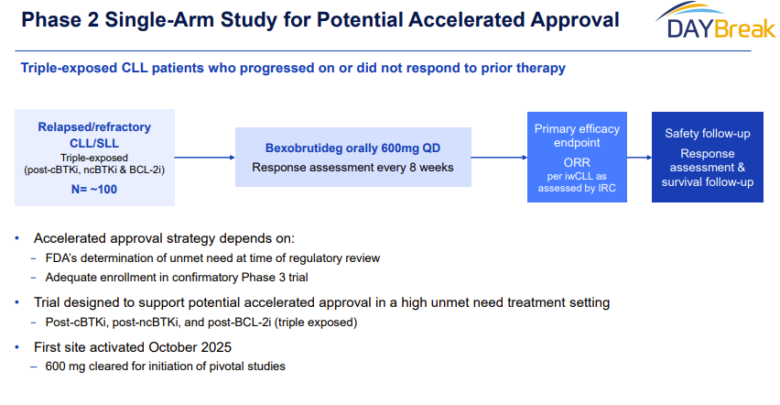
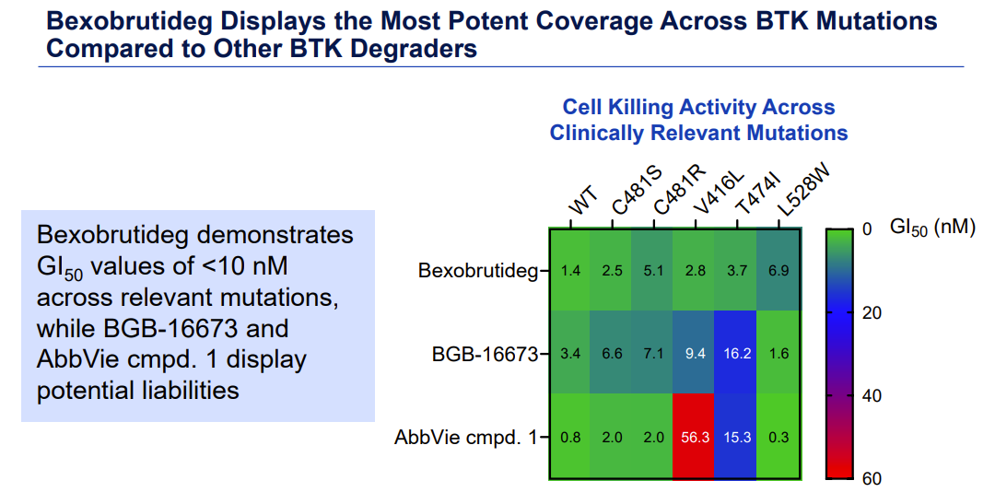
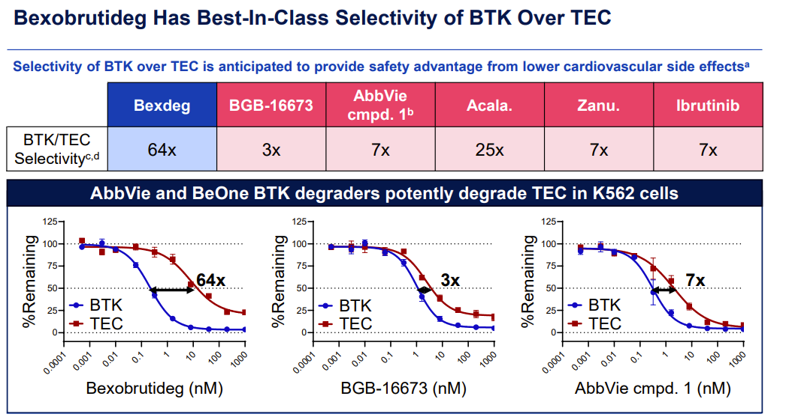

For questions, please reach out to:
International / Affiliates: Harjit Bajwa
US: Richa Sharma
Corporate Strategy, R&D and PCS: Claudia Lanauze Torres

Invite your colleagues to CI Edge | Manage Email Preferences | Unsubscribe

This document/email contains competitive intelligence collected via an approved competitive intelligence supplier working on behalf of AbbVie. We collect competitive intelligence consistent with industry standards and AbbVie policy. Not for field distribution. Please reach out to APEX/IMABI, Legal, or OEC teams with any questions.

